Engineering Tools-ENGR 110 Fall
Lab 2

PURPOSE: To begin to use the SolidWorks software. To continue the MATLAB tutorials.

DESCRIPTION:
SOLIDWORKS:
1. Complete the LESSON 1, Getting Started tutorial in THE SOLIDWORKS SOFTWARE. When you open the solidworks software, click on the TUTORIALS option. The figure looks like this:
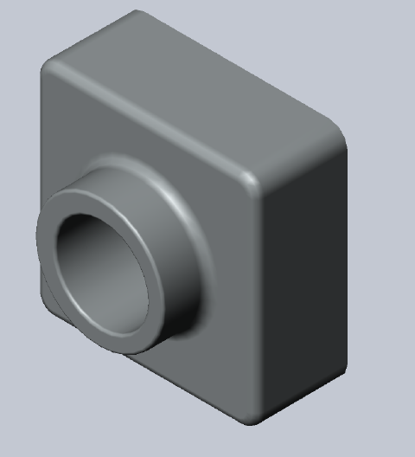
You do NOT have to create a SECTION VIEW at the very end of the tutorial so you can stop when you get to that part.

2. Complete the tutorial in chapter 1 of YOUR BOOK
Complete sections 1.1 and 1.2 in chapter 1. NOTE: For the lab, you do not have to complete sections 1.3, 1.4 and 1.5. However, it is recommended that you read through these sections and continue with the tutorial when you have time. The figure you produce should look like this (should be figure 1.99 in your text):
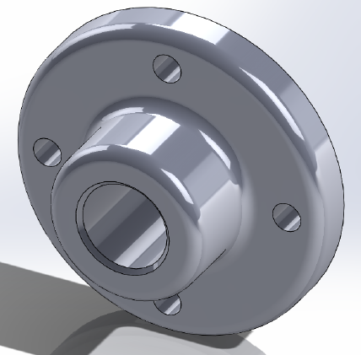

MATLAB work:
1. Complete Chapter 11 in the MATLAB ON RAMP tutorial program we have been using. This chapter speaks about how to write programs in MATLAB (called script files).

2. Enter the following program in to MATLAB as a new script file (click on the script file option is in the upper left hand corner of MATLAB software, type the program below, save it, and click on RUN to execute the program). You should type everything in purple EXACTLY as is.
%PROGRAM 1
% This is a practice script file
% This program will calculate the average of three test scores
Test1=75;
Test2=84;
Test3=79;
Avgtest=(Test1+Test2+Test3)/3;
fprintf(‘The average test score is %f ‘, Avgtest);

There is no user input required for this program. When you run this program, it should output the average of those 3 test scores. Notice that every time you execute this program it will always output the same average because it is always averaging the same three test scores!

3. Enter the following program in to MATLAB as a new script file like you did in problem 2 above. Execute this program by clicking on RUN. This program looks similar BUT is a lot more flexible than our first program. When you execute this program you will be able to enter any three test scores you want – this is user input. So, each time you execute this program, it can output a different average!
Again, type in everything in purple EXACTLY as written. Where it says “enter first test score” you should type ‘enter first test score’ and so on.

% This program finds the average of three test scores entered in the command window.
Test1= input(‘enter first test score’);
Test2= input(‘enter second test score’);
Test3= input(‘enter third test score’);
Avgtest=(Test1+Test2+Test3)/3;
fprintf(‘The average test score is %f’, Avgtest);

You will run this program two times. Use these values:
RUN 1: 68, 75, 91
RUN 2: 99, 92, 83

NOTE: Do not copy and paste these two programs in to MatLAB – the formatting identifiers in MSWord seem to create errors in the MatLAB programs.

DELIVERABLES:
A. Trimetric view of the CHAPTER 1 tutorial (tutorial from the textbook).
B. Trimetric view of the LESSON 1 tutorial (tutorial on the software) for Solidworks
C. MATLAB script file for PROGRAM 1 and a copy of the execution of this program.
D. MATLAB script file for PROGRAM 2 and a copy of BOTH executions for this program

EVALUATION:
Each Solidworks drawing is weighted equally for a total of 80 points.
The MATLAB work is worth 20 points.

